*WHAT IS HIGH VOLTAGE KIDS?*

IT’S WHERE *8-11 YEAR OLDS*

hivoltagekids slogan.png

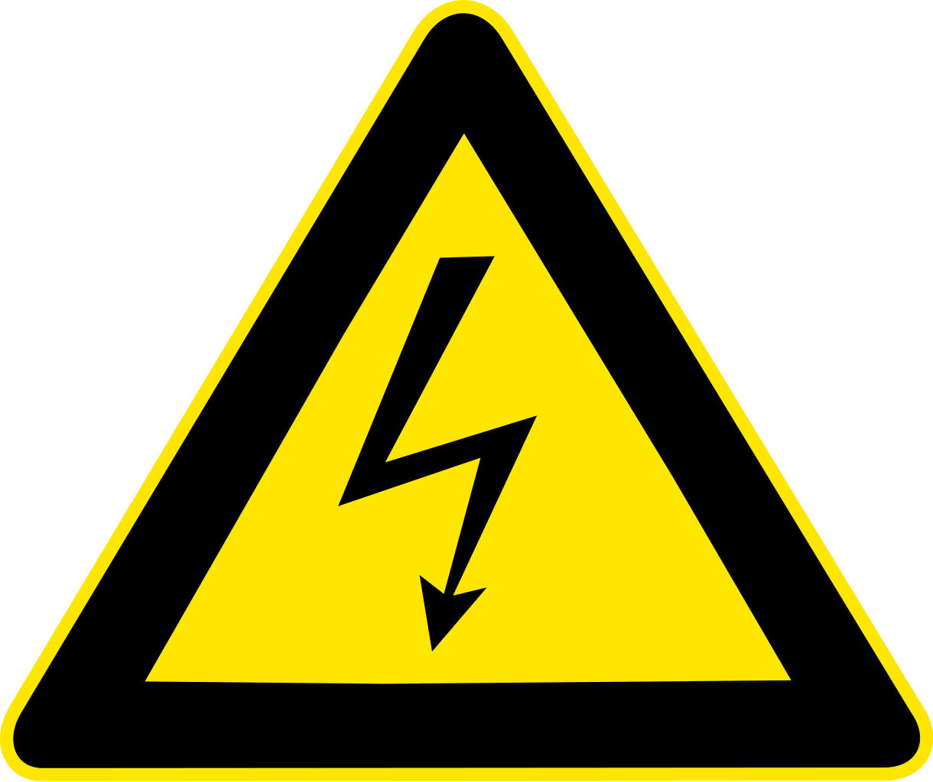

*Every Sunday* our *HIGH VOLTGAGE KIDS* meet in the HIGH VOLTAGE room after Praise & Worship for a “Media Rich - Teacher Driven" Bible Lesson!  In other words, *HIGH VOLTGAGE KIDS MINISTRY* uses all the high-tech video, graphics, sound effects, fun characters and other media elements that grab & keep your kid’s attention!

*MEDIA RICH—TEACHER DRIVEN!*

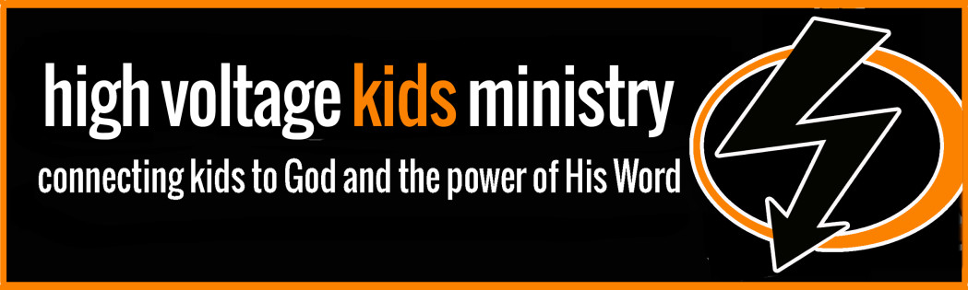

Our CLF Youth Team is determined to offer the most exciting Sunday morning ministry possible to your kids!  We believe that we have to work hard to keep your children engaged and we give it 110% every week!

High Voltage Kid's is a place where kids 8-11yrs old can learn about God on own their level in a **fun, safe, friendly, and kid-charged atmosphere.**

**HIGH VOLTGAGE KIDS will meet many fun & relatable characters each week. Characters such as:**

*COME & ENTER THE*

*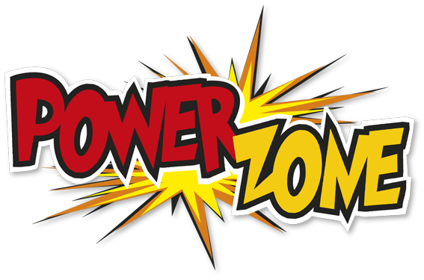 AND see what all the excitement is about at HIGH VOLTAGE KIDS! Join us every Sunday and let God Power Up Your Life!!*



***EVERY SUNDAY!***

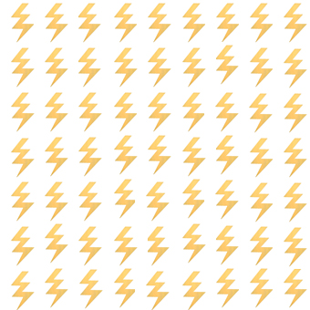



*CLFCHURCH.COM*

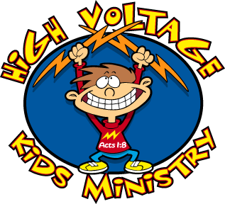***FOR 8-11 YEAR OLDS!***

clfchurch.com

***CHRISTIAN LIFE FELLOWSHIP’S***

***HIGH VOLTAGE KIDS 603-352-9471 ***